SonicWall connection

The purpose of this document is to show the steps to connect to the network using the sonicwall software. This document assumes the software has been installed and that you have a valid active directory id and password. We assume you may have the old Vincent connection still and that you have already imported the new connection file.

I going to select SWGVC shortcut.

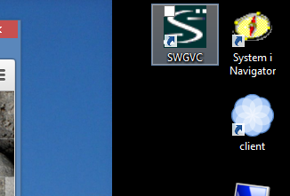Select the sonicwall software.

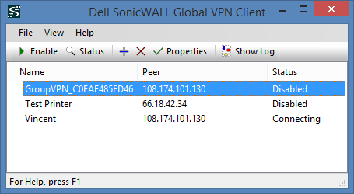

On mine the Vincent one tries to connect don't let it, disable it. If everything works correctly you can delete the Vincent one. Right click and select disable.

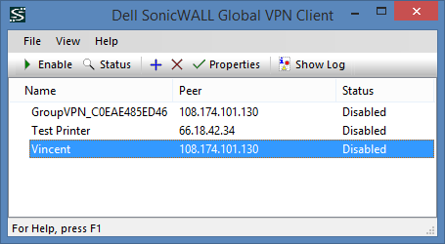

Start the new one by right clicking it and enable it.

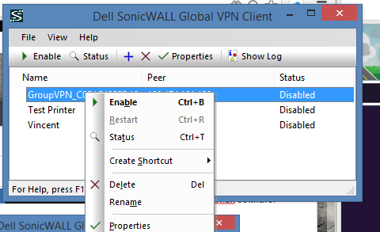

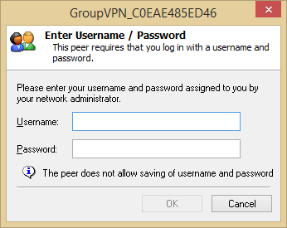

Enter your vincent id and password

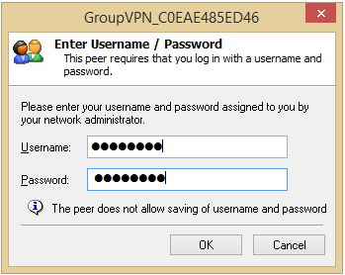

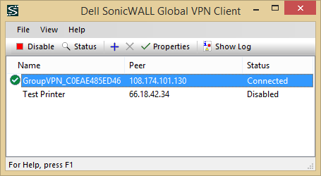

It should take less than minute if you have done everything correctly.

If you continue to have trouble send me the log so I can pass it on to techs.

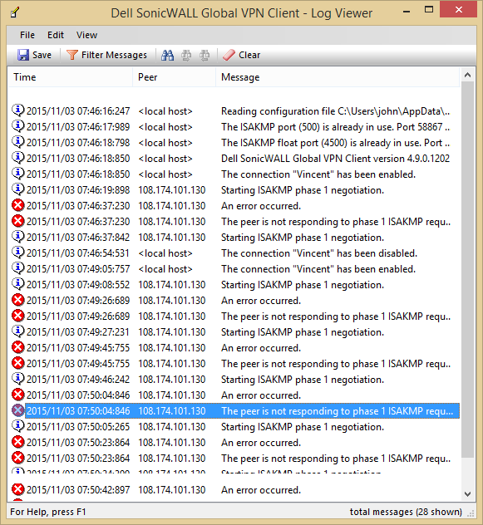

Do this if there is an error and before you try something else because it only records the last action. You can press the "Show Log" and get this information. Open the window more so we can see the messages and send this to us.

Or just save the file somewhere on your pc and email it to me.